**SUBMITTED BY: ALBIN JOSEPH**

**ROLLNO: MCA2305**

**Data Structure Project**

**PROJECT NAME: EXPENSE MANAGER**

**Features Implemented**

* Add expense
* Remove expense
* Set expense goal
* Display Expenses and Expense Goal
* Add notes
* Display notes
* Display spending tips
* Save expenses to a file

**Menu**

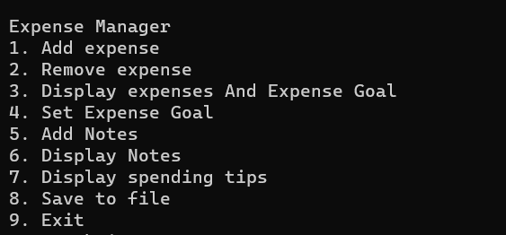

**ADDING EXPENSE**

Add expenses along with date and category.

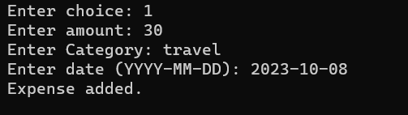

**REMOVE EXPENSE**

With this feature, you can delete or remove expenses that you've previously added. This can be useful if you make a mistake or if you no longer need to track a specific expense.

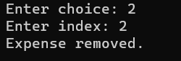

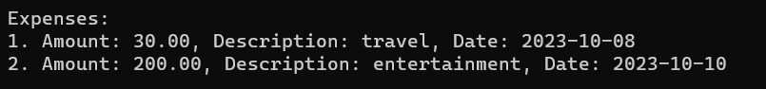

**DISPLAY EXPENSES AND EXPENSE GOAL**

Display the expenses as a list and also shows the total expenses and shows if you have exceeded the expense goal or not.

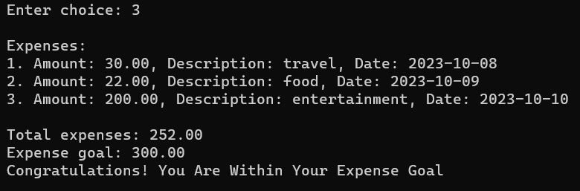

**SET EXPENSE GOAL**

Setting an expense goal allows you to define a specific financial target. This could be a monthly budget, a savings goal, or any other expense-related objective. The application will help you track your progress toward this goal.

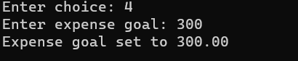

**ADD NOTES**

This feature allows you to add notes making it easier to understand your spending habits and you can also reduce your spending that way.

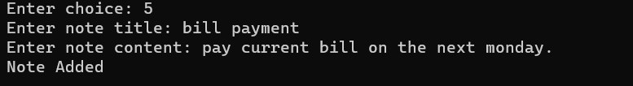

**DISPLAY NOTES**

You can display the notes you have previously added. You can analyse these notes and make appropriate decisions.

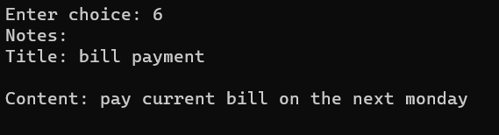

**DISPLAY SPENDING TIPS**

This functionality offers financial advice or tips on how to manage your expenses more effectively. It may provide insights on saving money, budgeting, or making smarter spending choices.

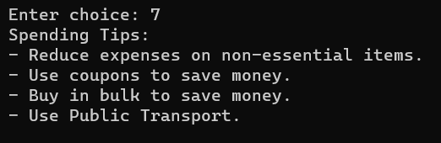

**SAVE EXPENSES ON FILE**

This feature enables you to save your expense data to a file. Saving to a file allows you to keep a backup of your financial records and analyse your spending over time.

